**Wessex Synod meeting – guide to how we are using Zoom**

Signing In

* Please try to ensure that your name as you sign in for the meeting is your full name (please do not use titles e.g. Revd. as this makes it hard to see your full name). If you are a voting member please add a capital V at the beginning of your name and if a non-voting member or visitor, please add an X e.g. V Karen Bell. This is best done by logging into Zoom from your browser before the meeting and changing it in your settings. It’s really unhelpful to have people labelled as ‘Fred’s iPad’ or by the make and model of a phone!
* Remember to log in at the times stated for voting and non-voting participants – you can leave your computer and have a cup of tea, so long as you arrive back before the start time of 6.30pm
* If your name is not clear, those dealing with registration will probably leave you until towards the end, as it will take them far more time to let you into the meeting
* If you have difficulty getting into the meeting, either at the start, or if you get cut off, try signing out, and signing back in again.
* If that doesn’t work, then you can contact Ray Stanyon on 07890 909 488‬ and he will do his best to help. Do be patient, especially during the registration period, as she will be very busy‬
* You will come into the meeting on Mute, when in the meeting room you see the message ‘Allow the Host to Unmute you’ please click on yes

What you can see on screen

* This will depend on what machine you are using
* It will be helpful to you to have the list of participants open, as this gives you access to various tools that we will be using. It looks like this and is normally at the bottom of the screen on a computer, the top on a tablet, and can be found by tapping the screen on a mobile phone
* Depending on the version of Zoom you have, the options we will use during Synod will show in the Reactions tab or the Participants tab

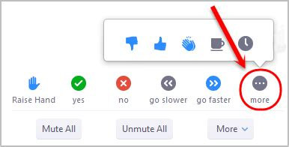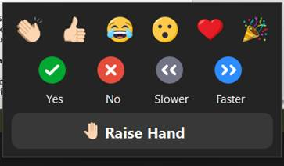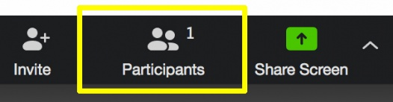

There are some options – looking something like this. We will be using the ‘raise hand’ ‘yes’ and ‘no’ functions throughout the meeting

Conducting our business

* Whilst holding the meeting online is different from a physical meeting, we will conduct business in a way which, to a great extent follows our normal pattern.
* If you will to speak in the meeting, then you need to click on the ‘raise hand’ icon. This puts you at the top of the participants list, and can be seen by the chair, who will ask people to speak, in the order in which hands are raised.
* If someone else makes the point you were going to bring, you can lower your hand by clicking the icon again
* Waving on screen, or using the ‘reactions’ button on the main Zoom screen will not be seen by the Moderator and Clerk
* Most of the time, you will be muted. When you are asked to speak, please unmute yourself, tell Synod who you are and where you are from, and then bring your point. If you don’t mute yourself after you have spoken, one of the tech support team will do this, as well as lowering your hand
* We will, as usual, split any debate into the three stages of ‘information/clarification, discussion, and decision
* 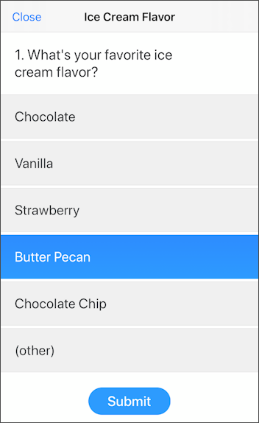If we want to ‘take the temperature’ of the meeting, we will ask you to use the ‘yes’ or ‘no’ buttons (see the previous picture). Yes would be equivalent to an orange card, and no a blue card. Both voting members and visitors are welcome to join in with this.
* When we reach a decision making point, we will use the ‘poll’ function. A box will appear on your screen, and voting members are asked to click the appropriate place. You then need to click on ‘submit’. There is a time limit to respond. Once the poll is finished the results can be shared with everyone.
* We will need to trust those who are visiting, rather than voting members, not to complete the polls. However, if the number of votes exceeds the number of voting members it will be noted, and if there is an issue around the validity of decisions, the support team could, if necessary, remove visitors into the ‘waiting room’ and reissue the poll.
* An audio recording of the meeting will be made, purely for the use of the minute taker. Once the minutes have been written it will be deleted. If you have any issue with this, please tell the Registration team as you arrive

Chat function

* The ‘chat’ function of Zoom will be available during the meeting. The icon for it is usually to the right of the ‘participants’ icon
* As you arrive, why not put in ‘chat’ a greeting from your church, that way we can get a sense of where we are all from.
* We will be putting in the ‘chat’ some web links and key items as the meeting goes on.
* Don’t forget, if you send a message to ‘everyone’... everyone will see it!
* Please use ‘chat’ wisely. Feel free to use it to reiterate a point that you have heard that you find helpful or inspiring…
* ...but please don’t use ‘chat’ in a negative way! We hope that this will be a very positive part of our Synod meeting.
* ‘Chat’ will be monitored for the Moderator and Clerk, but they will not be reading it all!
* The ‘chat’ will not be recorded.

Breakout rooms

* At some points in the meeting we may be split up into smaller groups in ‘breakout rooms’.
* 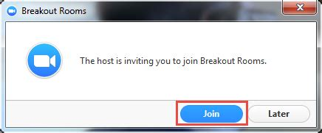Depending on the topic, they may be randomly assigned, or you will be put into the ‘room’ that you have chosen for a topic
* When breakout rooms are being used you will receive a message inviting you to join. Just press ‘join’.
* You will get messages to say when they are finishing. You will go back to the main room if you wait for the timer to finish

Staying connected

* Once you have signed in, if possible remain in the meeting. During breaks, or if you need to leave your computer for a while, make sure that you are muted, and if you 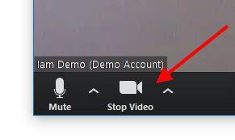wish, turn your video off, but don’t click on ‘leave meeting’, as this will mean that you will come back into the ‘waiting room’